2011.R

Suraj Durgesht(16EC06)

Mon Feb 18 09:23:03 2019

library(ggplot2)  
library(ggthemes)  
library(pdftools)  
library(cowplot)

df <- read.csv("D:\\Programming\\DA\\Lab 2\\2011\\2011.csv", header = T)  
  
summary(df)

## Sr..No District Birth.Registered Birth.Rate   
## Min. : 1.00 BAGALKOTE : 1 Min. : 4716 Min. :12.80   
## 1st Qu.: 8.25 BANGALORE (R): 1 1st Qu.: 15012 1st Qu.:16.52   
## Median :15.50 BANGALORE (U): 1 Median : 18612 Median :17.93   
## Mean :15.50 BELGAUM : 1 Mean : 25606 Mean :18.42   
## 3rd Qu.:22.75 BELLARY : 1 3rd Qu.: 29383 3rd Qu.:20.57   
## Max. :30.00 BIDAR : 1 Max. :141434 Max. :24.59   
## (Other) :24   
## Death.Regesterd Death.Rate Registered.Infant.Death  
## Min. : 884 Min. :3.980 Min. : 9.00   
## 1st Qu.: 2161 1st Qu.:5.665 1st Qu.: 87.25   
## Median : 3639 Median :6.300 Median : 135.00   
## Mean : 5753 Mean :6.201 Mean : 273.27   
## 3rd Qu.: 5564 3rd Qu.:6.740 3rd Qu.: 360.75   
## Max. :48611 Max. :8.370 Max. :1216.00   
##   
## Still.Birth.Registered Still.Birth.Rate  
## Min. : 4.0 Min. : 0.000   
## 1st Qu.: 26.0 1st Qu.: 1.323   
## Median :217.0 Median : 4.265   
## Mean :217.8 Mean : 5.062   
## 3rd Qu.:327.0 3rd Qu.: 8.918   
## Max. :868.0 Max. :13.370   
## NA's :1

var(df$Birth.Registered)

## [1] 609322101

sd(df$Birth.Registered)

## [1] 24684.45

head(df)

## Sr..No District Birth.Registered Birth.Rate Death.Regesterd  
## 1 1 BAGALKOTE 35199 18.74 5119  
## 2 2 BANGALORE (R) 7479 12.80 1722  
## 3 3 BANGALORE (U) 141434 14.28 48611  
## 4 4 BELGAUM 54881 14.99 10951  
## 5 5 BELLARY 28309 21.87 6728  
## 6 6 BIDAR 24793 19.08 2370  
## Death.Rate Registered.Infant.Death Still.Birth.Registered  
## 1 6.06 234 426  
## 2 5.66 27 4  
## 3 4.88 1216 264  
## 4 6.80 516 868  
## 5 6.00 372 335  
## 6 3.98 188 343  
## Still.Birth.Rate  
## 1 10.35  
## 2 0.29  
## 3 2.00  
## 4 13.37  
## 5 6.85  
## 6 4.18

tail(df)

## Sr..No District Birth.Registered Birth.Rate Death.Regesterd  
## 25 25 RAMANAGAR 9712 22.55 1885  
## 26 26 SHIMOGA 29433 16.48 5713  
## 27 27 TUMKUR 29496 19.57 4428  
## 28 28 UDUPI 16463 17.51 3770  
## 29 29 UTTARA KANNADA 22150 17.69 3096  
## 30 30 YADGIR 4716 17.37 1074  
## Death.Rate Registered.Infant.Death Still.Birth.Registered  
## 25 6.25 9 6  
## 26 6.97 327 329  
## 27 6.60 110 32  
## 28 5.12 125 136  
## 29 6.35 101 173  
## 30 5.20 19 NA  
## Still.Birth.Rate  
## 25 0.00  
## 26 6.89  
## 27 1.14  
## 28 0.67  
## 29 7.00  
## 30 0.78

a <- ggplot(df, aes(Birth.Rate, Birth.Registered, colour = "Birth"))+   
 geom_point()+ ggtitle("Birth registered VS rate")+theme_bw()+  
 theme(legend.position = c(0.8, 0.8))+geom_line()  
b <- ggplot(df, aes(Death.Rate, Death.Regesterd, colour = "Death"))+   
 geom_point()+ ggtitle("Death registered VS rate")+theme_bw()+  
 theme(legend.position = c(0.8, 0.8))+geom_line()  
c <- ggplot(df, aes(Still.Birth.Rate, Still.Birth.Registered, colour = "Still Birth")) +  
 geom_point()+ ggtitle("Still Birth registered VS rate")+theme_bw()+  
 theme(legend.position = c(0.3, 0.8))+geom_line()  
d <- ggplot(df, aes(Sr..No, Registered.Infant.Death, colour = "Infant"))+   
 geom_point()+ ggtitle("Still Infant registered VS rate") + theme_bw()+  
 theme(legend.position = c(0.3, 0.8))+geom_line()  
  
plot_grid(a, b,c,d, labels = "AUTO")

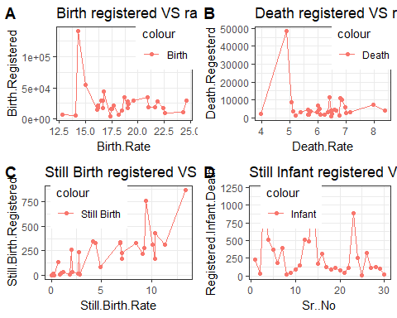

p <- ggplot(df, aes(Birth.Registered)) + geom_histogram(colour="green") +   
 ggtitle("Birth Registered")   
q <- ggplot(df, aes(Birth.Rate)) + geom_histogram(colour="green") +   
 ggtitle("Birth Rate")   
r <- ggplot(df, aes(Death.Regesterd)) + geom_histogram(colour="green") +   
 ggtitle("Death Registered")   
s <- ggplot(df, aes(Death.Rate)) + geom_histogram(colour="green") +   
 ggtitle("Death Rate")   
t <- ggplot(df, aes(Registered.Infant.Death)) + geom_histogram(colour="green")+  
 ggtitle("Registered Infant Death")   
u <- ggplot(df, aes(Still.Birth.Registered)) + geom_histogram(colour="green") +  
 ggtitle("Still Birth Registered")   
v <- ggplot(df, aes(Still.Birth.Rate)) +   
 geom_histogram(colour="green") + ggtitle("Still Birth Rate")   
  
plot_grid(p,q,r,s, labels = "AUTO")

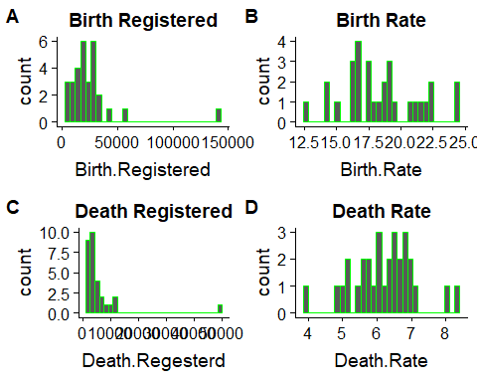

plot_grid(t,u,v, labels = "AUTO")

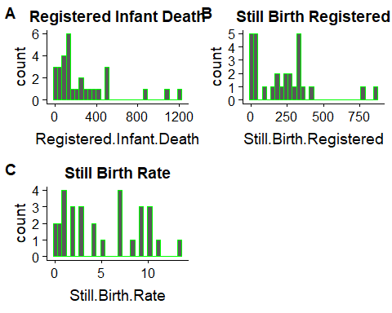

g <- ggplot(df, aes(Birth.Registered, Birth.Rate)) +   
 geom_boxplot(fill = "white", colour = "#3366FF", outlier.colour = "red",   
 outlier.shape = 1)+ geom_jitter(width = 0.2)  
y <- ggplot(df, aes(Death.Regesterd, Death.Rate)) +   
 geom_boxplot(fill = "white", colour = "#3366FF", outlier.colour = "red",   
 outlier.shape = 1)+geom_jitter(width = 0.2)  
z <- ggplot(df, aes(Still.Birth.Registered, Still.Birth.Rate)) +   
 geom_boxplot(fill = "white", colour = "#3366FF", outlier.colour = "red",   
 outlier.shape = 1)+geom_jitter(width = 0.2)  
  
plot_grid(g,y,z, labels = "AUTO")

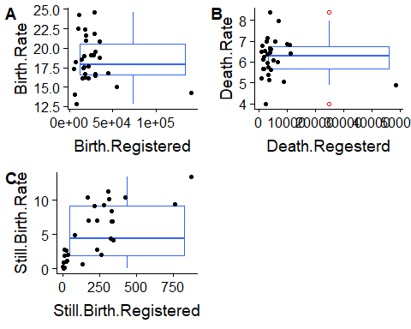

aa <- qqplot(df$Birth.Registered, df$Birth.Rate, col = "green")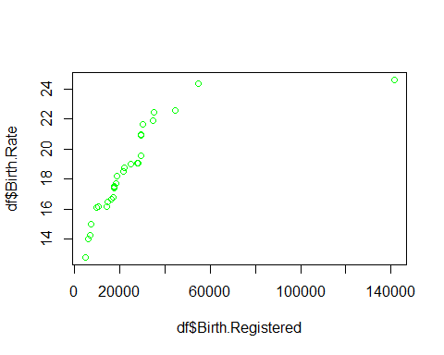

bb <- qqplot(df$Death.Regesterd,df$Death.Rate, col = "red")

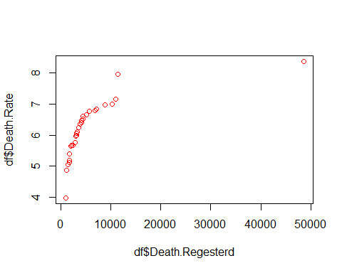

cc <- qqplot(df$Still.Birth.Registered, df$Still.Birth.Rate, col = "blue")

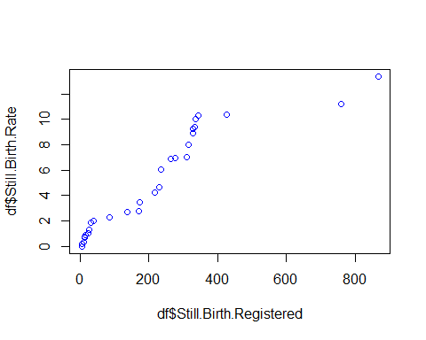

ggplot(df) + theme_fivethirtyeight(base_size = 12, base_family = "sans") +  
 scale_shape_manual(values=1:nlevels(df$sn)) +  
 geom_bar(aes(y = Birth.Registered, x = Sr..No, fill = District),   
 stat = "identity", position = "dodge")

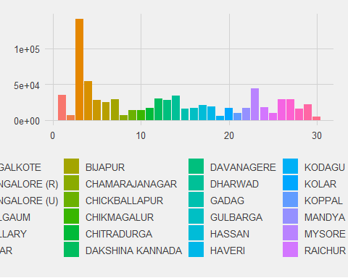

ggplot(df, aes(District ,Birth.Registered)) +  
 theme(axis.text.x = element_text( angle = 45, hjust = 1))+  
 geom_point(colour="black", size = 3.75) +  
 geom_point(colour="blue", size = 2.5)

